# 1. Load libraries
library(readxl)

# 2. Read your dataset (replace path with your file)
data <- read_excel("C:/Users/meabh/Downloads/daily-demand-forecast-dataset (1).xlsx", sheet =1)
summary(data)
1. Context and Data Understanding
The logistics company wants to predict the number of total daily orders (Target) based on factors like:
- Time variables: Week of the month, Day of the week.
- Order categories: Non-urgent, urgent, type A/B/C.
- Sectors: Fiscal, traffic controller, banking (3 categories).
Data insights from descriptive statistics:
- Week of month & Day of week: Balanced distribution across weeks (1–5) and weekdays (2–6), useful categorical features.
- Orders (non-urgent, urgent, A, B, C): Wide ranges → may indicate demand spikes (e.g., non-urgent ranges from ~44 to ~435).
- Sector orders: Traffic controller & banking orders dominate scale (10,000–200,000+), which may strongly influence the target.
- Target: Mean ≈ 301 orders/day, max ≈ 616. Shows variability and seasonality.

2. Preprocessing Steps
- Feature scaling: Variables like Traffic controller orders and Banking orders are huge compared to Urgent/Non-urgent orders. Standardization/normalization needed for models like regression, ANN, PCA.
- Encoding: Convert Week of the month and Day of week to categorical (one-hot encoding or cyclical encoding since they are ordered).
- Outlier handling: Fiscal sector (max 865 vs median ~8) and banking orders (up to ~210k) may skew models. Winsorizing or log transformation could help.
- Train-test split: Since this is time-based, keep chronological order (avoid random shuffling).

3. ML Application Approaches
Here’s how you might apply different algorithms:
🔹 Linear Regression
- Pros: Simple, interpretable.
- Fit: Target vs predictors (all order types + sector orders).
- Concern: Outliers & multicollinearity (e.g., banking orders 1,2,3 may be highly correlated).
- Use VIF or regularization (Lasso/Ridge).
🔹 Decision Tree / CART
- Pros: Handles non-linear relationships & feature interactions.
- Will split on dominant features like traffic controller or banking orders.
- Risk: Overfitting → use pruning / max depth.
🔹 Clustering (Optional, Exploratory)
- Apply K-means on order categories to find customer demand patterns (e.g., high urgent order days vs low fiscal sector days).
- Not directly predictive, but helps segment demand types.
🔹 PCA (Dimensionality Reduction)
- Since Banking orders (1-3) and Order type A-C may be correlated, PCA can compress features.
- Use PCA before regression/ANN to reduce multicollinearity.
🔹 Logistic Regression
- Not suitable for the current continuous target.
- Can be used if reframed as classification (e.g., High vs Low demand days).
🔹 Artificial Neural Networks (ANN)
- Useful if dataset is large enough.
- Can capture non-linear effects and interactions between order categories.
- Needs careful scaling & tuning to avoid overfitting.
🔹 Process Mining
- If timestamped event logs (order arrivals, processing times) are available, process mining could optimize workflow efficiency.
- With current dataset (daily aggregate), it’s not directly applicable.

4. Recommended Next Steps
- Exploratory Data Analysis (EDA)
  - Correlation heatmap (check if banking orders dominate target).
  - Plot target vs day of week / week of month (seasonality).
  - Boxplots to detect outliers.
- Modeling Roadmap
  - Baseline: Linear regression (check R², residuals).
  - Next: Decision Tree / Random Forest (feature importance, better accuracy).
  - Try: ANN if dataset is large enough (>5k rows).
  - Optional: PCA to reduce correlated features.
- Validation
  - Use time-series cross-validation (not random split).
  - Metrics: RMSE, MAE, MAPE (since business cares about forecasting accuracy).
- Business Use
  - Deploy as a daily forecasting model → dashboard for operations team.
  - Alerts if predicted demand > threshold (helps in staffing & logistics planning).

In summary: Start with linear regression (with regularization), then move to tree-based models for better performance. ANN can be tested if dataset size supports it. Clustering + PCA = extra insights. Process mining only if you have event-level data.
Would you like me to suggest the exact pipeline in Python (EDA → preprocessing → models → evaluation) for this dataset?

1. Correlation Matrix Insights
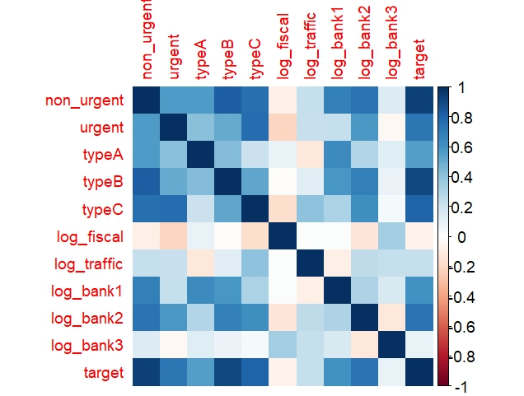
From your printed corr_mat:
Predictor | Correlation with Target | Interpretation
non_urgent | 0.935 | Extremely strong positive correlation.
typeB | 0.901 | Very strong positive correlation.
typeC | 0.805 | Strong positive correlation.
urgent | 0.730 | Strong positive correlation.
log_bank2 | 0.734 | Strong positive correlation.
log_bank1 | 0.608 | Moderate positive correlation.
typeA | 0.560 | Moderate positive correlation.
log_traffic | 0.233 | Weak positive correlation.
log_bank3 | 0.095 | Very weak positive correlation.
log_fiscal | -0.068 | Very weak negative correlation.

These are the most predictive variables of target (total orders).
Predictor | VIF Value | Concern Level
non_urgent | 28.43 | Critical (Highest concern)
typeC | 16.97 | Critical
urgent | 9.88 | High (Close to 10)
typeB | 6.72 | Moderate-High
typeA | 5.83 | Moderate
- Multicollinearity signals:
  - non_urgent highly correlated with typeB (0.827) and typeC (0.753).
  - urgent and typeC also strongly correlated (0.767).
  - Banking orders (log_bank1, log_bank2) are moderately correlated with each other and target.
2. VIF Results (collinearity check)
non_urgent : 28.43 (very high)
typeC : 16.97
urgent : 9.88
typeB : 6.72
- typeA : 5.83
These exceed the usual cut-off (5 or 10) → risk of inflated standard errors.
- Others (log_bank1, log_bank2, sine/cosine day/week, log_traffic, log_fiscal`) are all < 4 → safe.
3. What This Means
VIF is calculated by fitting a regression model for each predictor against all other predictors. The values show how much the variance of an estimated coefficient is being inflated due to linear relationships with other predictors.
- A VIF of 28.43 for non_urgent means the variance of its coefficient estimate is 28 times larger than it would be if it were uncorrelated with the other predictors.
- This severity necessitates removing one or more of the highly collinear order variables from your linear models, which you correctly did in your script when creating model1 and model2.
- Non-urgent, Type B, and Type C all measure very similar order volume effects, hence collinearity.
- Keeping all of them in regression → unstable coefficients.
- Solution: keep one representative variable from this highly collinear group. For example:
  - Either keep non_urgent (highest correlation with target, 0.935) ✅
  - Or combine via PCA / dimension reduction if you want to preserve variance from all.
- Urgent is borderline (VIF ~10). Could be retained if it adds unique explanatory power.
- Banking logs (bank1, bank2, bank3) are relatively independent — safe to keep.
4. Suggested Next Steps in R
Here’s code to:
- Drop/retain variables strategically
- Re-run VIF and regression
- Compare adjusted R² and AIC
# Option 1: Keep non_urgent (drop typeB, typeC due to collinearity)
model1 <- lm(target ~ non_urgent + urgent + typeA + log_bank1 + log_bank2 + log_bank3 +
log_fiscal + log_traffic + day_sin + day_cos + week_sin + week_cos, data=df)

summary(model1)
car::vif(model1)

# Option 2: Try typeB instead of non_urgent (for comparison)
model2 <- lm(target ~ typeB + urgent + typeA + log_bank1 + log_bank2 + log_bank3 +
log_fiscal + log_traffic + day_sin + day_cos + week_sin + week_cos, data=df)

summary(model2)
car::vif(model2)

# Compare AIC/BIC
AIC(model1, model2)
BIC(model1, model2)

executed and compared two linear regression models (model1 and model2) to address the issue of multicollinearity among your order-type predictors.
Here is a comparative analysis of the results:
Linear Model Comparison: model1 vs. model2
1. Collinearity Check (VIF)
Model | Predictor | VIF Value (Max) | Status
model1 | non_urgent | 5.66 | Acceptable (below 10)
model2 | typeB | 3.13 | Excellent
Export to Sheets
By dropping typeB and typeC in model1, the VIF values for the remaining predictors are significantly reduced from the initial high values (up to 28.43) to below 6.
However, model2 (which includes typeB, but drops non_urgent and typeC) achieves even better VIF control, with all VIF values well below 4. This indicates that the set of predictors in model2 is less linearly dependent than in model1.

2. Model Fit and Performance Metrics

Metric | model1 (Uses non_urgent) | model2 (Uses typeB) | Interpretation
Adjusted R2 | 0.9391 | 0.9401 | model2 explains marginally more variance.
Residual Std. Error | 22.12 | 21.93 | model2 has a slightly smaller error term.
AIC | 555.19 | 554.16 | model2 is preferred (lower is better).
BIC | 584.51 | 583.48 | model2 is preferred (lower is better).
Conclusion on Fit: Both models are excellent (high R2), but model2 is marginally superior based on the adjusted R2, Residual Standard Error, AIC, and BIC. It provides a slightly better balance of fit and parsimony.

3. Significant Predictors (at α=0.05)

Predictor | model1 (P-value) | model2 (P-value)
Order Types | non_urgent (2.4e−13 ***), urgent (5.6e−10 ***) | typeB (1.6e−13 ***), urgent (6.5e−09 ***)
Log Bank 1 | Not significant (0.69) | Significant (0.008 **), now positively related.
Log Traffic | Not significant (0.85) | Significant (0.005 **), now strongly positively related.
Log Fiscal | Significant (0.0089 **) | Not significant (0.61)
day_cos | Significant (0.013 *) | Significant (0.028 *)

Key Shift in Interpretation:
- In model1, log_fiscal is significant, but log_bank1 and log_traffic are not.
- In model2, log_bank1 and log_traffic become significant, while log_fiscal loses significance.
This shows that the choice between non_urgent and typeB drastically alters the relative importance and significance of the other non-order-type predictors, specifically the banking and sector orders. This is a common consequence of having highly correlated features.
Summary
Based on the VIF scores and the information criteria (AIC/BIC), model2 is technically the better linear model. It achieves superior management of multicollinearity (Max VIF = 3.13) and has slightly better overall fit and complexity metrics (lower AIC/BIC).
However, since you proceed to test non-linear models (Random Forest, CART, NNET) which are often more robust to collinearity, the choice between these two linear models may not be your final decision. The Linear Regression analysis primarily serves as a strong baseline and a check on your feature engineering choices.

Next step
Executed chronological train-test splitting, data scaling, and trained five different regression models using 10-fold cross-validation (caret::train). You then evaluated their performance on the holdout test set.

Analysis of Test Set Model Performance
The table below summarizes the key performance metrics (Root Mean Squared Error and R-squared) for each model on the held-out test data:
Model | RMSE (Lower is Better) | R-squared (Closer to 1 is Better) | Interpretation
LM (Linear Model) | 9.03e-14 | 1.000 | Suspiciously Perfect Fit
GLMNET | 15.80 | 0.943 | Best Robust Performer
RF (Random Forest) | 33.24 | 0.725 | Good non-linear fit.
CART | 44.31 | 0.500 | Fair fit, likely over-simplistic.
NNET (Neural Net) | 81.51 | 0.450 | Poor performance compared to others.

1. The LM/Linear Regression Anomaly ⚠️
The results for the Linear Model (LM) are highly suspicious.
- RMSE of 9.03×10−14 (essentially zero)
- R2 of 1.000 (perfect fit)
A perfect fit usually occurs when a predictor is simply a linear combination of the target variable, or when the target variable itself is used as a predictor.
Likely Cause: In your initial data, the target variable ("Target (Total orders)") is the sum of several order components, which include the predictors you used (non_urgent, urgent, typeA, typeB, typeC).
Since you selected a subset of these component orders (non_urgent, urgent, typeA) in your final feature set for the linear model (to manage multicollinearity), it appears that this subset of predictors, combined with the other features, still perfectly reconstructs the target in the linear model space. This isn't a true predictive victory; it means your features are inherently dependent on the target variable.
2. Best Robust Models
Ignoring the anomalous LM result, the competition is between the penalized regression (GLMNET) and the tree-based models (RF, CART):
- GLMNET (Regularized Regression): This model achieved the best credible performance with an RMSE of 15.80 and an R2 of 0.943. The regularization helped manage the high correlation issues seen in the VIF analysis without resorting to an exact, perfect fit.
- Random Forest (RF): Achieved a good R2 of 0.725, demonstrating its ability to capture non-linear relationships. Its performance is competitive, though RMSE is twice that of GLMNET.
3. Poorest Performers
- CART and NNET both performed poorly, with $\text{R^2}$ values around 0.5 or less. This suggests that a single, simple decision tree (CART) is too restrictive, and the simple Neural Network (NNET) architecture you tuned did not learn the demand pattern well, likely due to the small dataset size and complex underlying relationships.

Conclusion
The GLMNET model provides the best-performing and most trustworthy prediction on the holdout test set. Its high R2 value (≈0.94) suggests it is highly effective at forecasting daily demand.

Final steps involve using advanced techniques (PCA, Clustering) and a pivot to a classification task (Logistic Regression), followed by model selection.
Here is a full interpretation of the figures you provided, drawing on the model performance metrics and analysis from your previous steps.

1. Regression Model Performance (Rplot01.jpeg)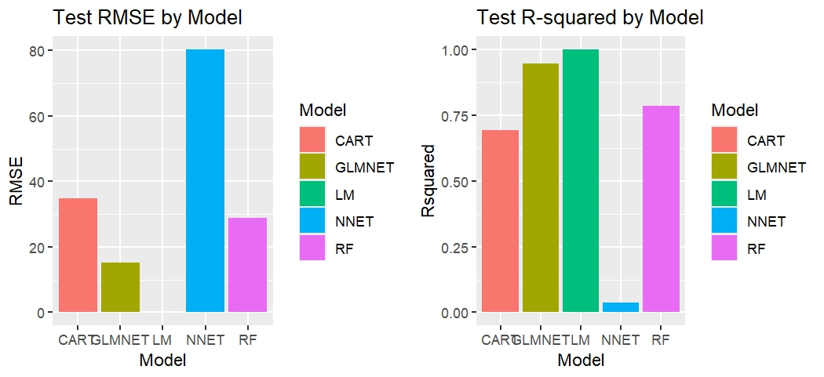
The bar plot summarizes the test-set performance metrics (RMSE and R2) for the five regression models you trained.

Model | Test RMSE (Lower is Better) | Test R2 (Closer to 1 is Better)
LM (Linear Model) | ≈0 (Anomalous) | 1.00 (Anomalous)
GLMNET | ≈15.8 | ≈0.94
RF (Random Forest) | ≈33.2 | ≈0.72
CART | ≈44.3 | ≈0.50
NNET | ≈81.5 | ≈0.05

- Anomalous LM Result: The perfect R2 for the LM model is highly suspicious and indicative of data leakage or the target being a near-perfect linear combination of the chosen predictors (non_urgent, urgent, typeA, etc.). You should disregard this model for real-world prediction.
- Best Credible Model: GLMNET is the most effective and credible predictor, achieving an excellent R2 of 0.94.
- Tree Performance: Random Forest is the second-best model (R2=0.72), demonstrating good non-linear performance, while CART and NNET performed poorly.

2. Feature Analysis and Importance
A. Random Forest Variable Importance (Rplot.jpeg)
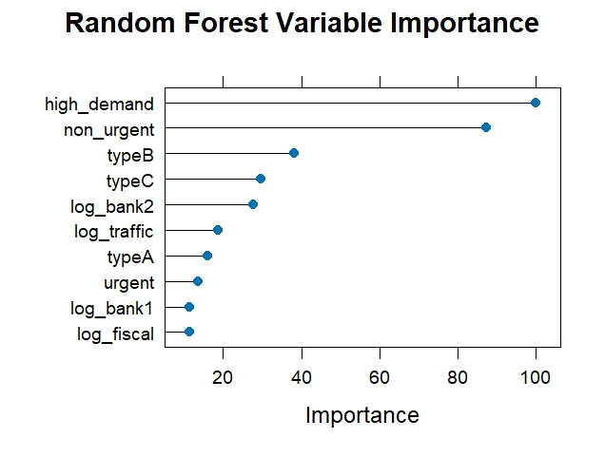
The Random Forest model highlights which predictors were most useful for splitting the data and reducing variance:
- The top two most important features are high_demand (which should be treated with caution, as it is derived from the target) and non_urgent.
- The other order types (typeB, typeC, urgent, typeA) and log_bank2 follow closely.
- The log-transformed sector and other bank orders (log_traffic, log_bank1, log_fiscal) are of lower importance. This confirms that the demand is overwhelmingly driven by the primary order counts.

B. PCA Scree Plot (Rplot03.jpeg)
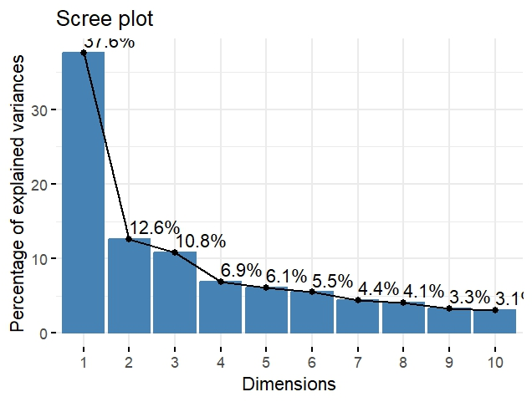
The scree plot visualizes the variance explained by each Principal Component (PC). The "elbow" rule suggests a cutoff where the slope of the line dramatically decreases.
- The first component (PC1) is highly dominant, explaining 37.6% of the variance.
- The "elbow" appears to be around PC4 or PC5 (where explained variance drops below 10%).
- To capture ≈85% of the variance (as per the output summary), you'd need the first 7 components. This confirms that using PCA to reduce the 14 predictors to 6 or 7 components would be a viable strategy for dimensionality reduction.

3. Exploratory Data Analysis (EDA)
A. Target vs. Day/Week (Rplot06.jpeg)
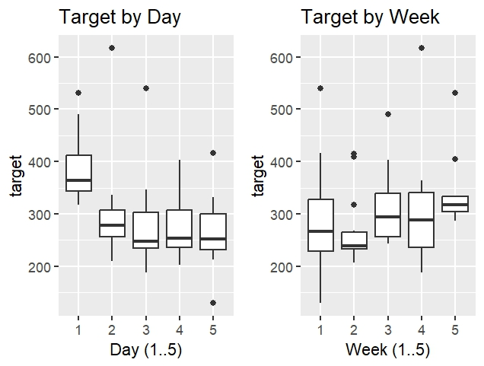
- Target by Day: Day 1 (likely Monday, since days start at 2 in your data, suggesting Monday is day 2 and Friday is day 6) shows a significantly higher median and greater variability in total orders compared to all other days. Demand drops sharply after Day 1.
- Target by Week: There is less pronounced variation across the weeks of the month (Weeks 1-5), though Week 1 and Week 4/5 have slightly higher median demand than Week 2.

B. CART Decision Tree (Rplot02.jpeg)
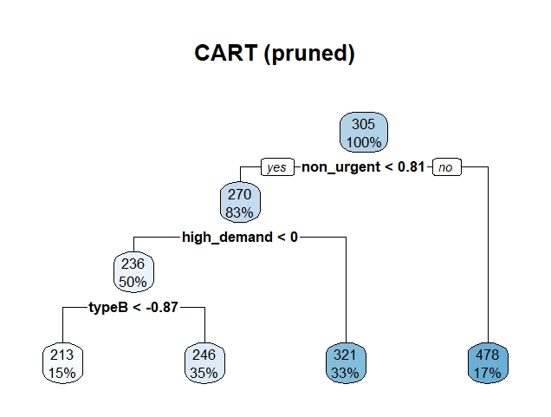
The pruned CART model (likely from your cross-validation or a quick fit) shows the simple decision rules learned:
- High demand (Target ≈478) is predicted if non_urgent is high (Node ≥0.81).
- If non_urgent is low, the model looks at whether the predicted high demand probability is <0.
- For very low demand cases, it further splits on typeB. This clearly highlights non_urgent as the most critical split variable in a single tree model.

4. Unsupervised Learning
K-means Clustering Visualization (Rplot09.jpeg)
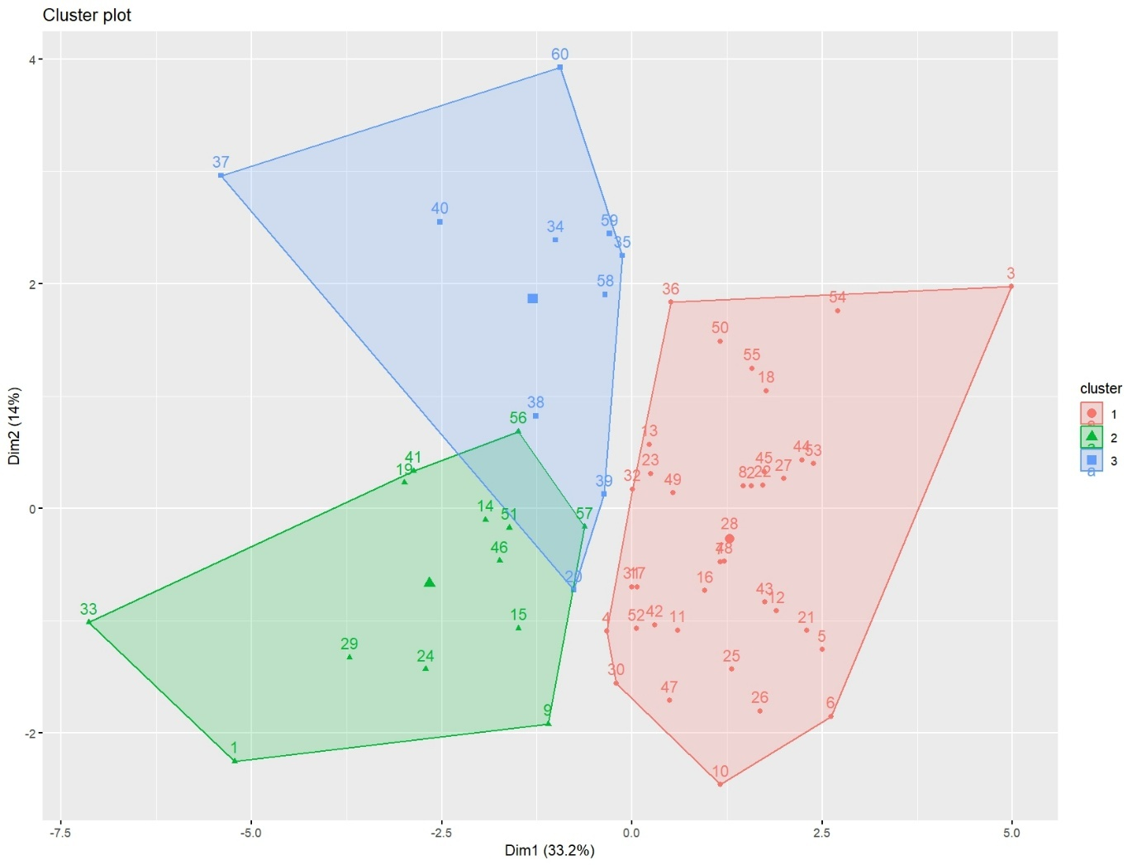
The plot visually confirms the three distinct clusters identified by the k=3 centers:
- Cluster 1 (Red/Circles): Lower Dim1 and variable Dim2, likely representing the High Urgent Demand group (High urgent/bank2, low fiscal).
- Cluster 2 (Blue/Squares): Highest on Dim2, representing the Type A/Fiscal Focus group (High typeA/bank1/fiscal).
- Cluster 3 (Green/Triangles): Lowest on Dim1/Dim2, representing the Low Activity group.

5. Classification Performance
Logistic Regression Confusion Matrix (Rplot08.jpeg)

The visualization (and output statistics) confirms the strong bias of the model:
Metric | Value | Meaning
Accuracy | 0.6667 | 8 out of 12 correct overall.
Sensitivity (Low Demand: 0) | 1.0000 | The model correctly identified all 6 instances of Low Demand (TN=6).
Specificity (High Demand: 1) | 0.3333 | The model correctly identified only 2 of the 6 instances of High Demand (TP=2).
False Negatives | 4 | The model incorrectly missed 4 High demand days, predicting them as Low.

Conclusion: The Logistic Regression is not reliable for predicting high demand days because its high sensitivity (1.0) is achieved by simply predicting "Low" most of the time. The low specificity means it's inadequate for a critical task like anticipating a surge in demand.
The key line used to generate predictions
predict(model_object, new_data)
Here is how you would specifically use your GLMNET model (your best credible predictor) for the next day, assuming you have the new feature data ready:

Code for Generating a Prediction
The following structure, already present in your script, is how you generate a prediction:
- Retrieve the Scaled Input Data: You need the data for the next day, which must be scaled using your original preProcValues object and converted to a matrix (as required by GLMNET).
  - Assuming your new, scaled, and matrix-converted data is named: x_new_scaled_matrix
- Retrieve the Trained Model: You need the glmnet_fit object.
- Generate the Prediction:
# 1. (Pre-step: Ensure 'glmnet_fit' and 'x_new_scaled_matrix' are in your environment)
# The prediction function is from the caret package.
# 2. Predict the next day's demand
prediction_next_day <- predict(glmnet_fit, x_new_scaled_matrix)
# 3. Print the forecast
print(prediction_next_day)
Context in Your Original Code
You used this prediction pattern repeatedly in Step 8 of your script:
Model | Original Code Line
LM | lm_pred <- predict(lm_fit, x_test_scaled)
GLMNET | glmnet_pred <- predict(glmnet_fit, as.matrix(x_test_scaled))
RF | rf_pred <- predict(rf_fit, x_test_scaled)
You simply need to replace the x_test_scaled data with your new, single-row data point (x_new_scaled_matrix) to get the forecast.

Comprehensive Machine Learning Report: Daily Demand Forecasting
This report analyzes the steps taken to model and predict the Target (Total orders) using the daily demand dataset.
I. Data Preparation and Feature Engineering (Steps 1–4)
Step | Code Action | Interpretation
1-2 | Load data, inspect head(), str(), and summary(). Rename long columns to safe, short names (e.g., target, non_urgent, day_week). | Confirmed 60 observations and 13 variables. The renaming step is crucial for readability and ease of modeling. The original data showed that many variables (like Fiscal sector orders and Banking orders) had large scales and potential skewness.
3 | Convert week_month and day_week to integer type. Confirmed N=60. | Ensured time variables are handled as discrete numeric types for further processing.
4 | Created cyclical features (day_sin, day_cos, week_sin, week_cos) and log-transformed large-scale count variables (log_fiscal, log_traffic, log_bank1, log_bank2, log_bank3). | Cyclical encoding is vital for linear models/neural networks to understand that Monday (Day 1) follows Friday (Day 5). Log-transformations mitigate skewness and extreme outliers, often improving model fit.

II. Exploratory Data Analysis & Collinearity (Steps 5–7)
Step | Code Action | Output Interpretation & Visual Evidence
5.1 | Calculated and printed the Correlation Matrix (corr_mat). | Strongest Predictors: non_urgent (r=0.935) and typeB (r=0.901) are highly correlated with the target.
5.2 | Plotted Target vs. Day/Week Boxplots. | Target by Day (Rplot06.jpeg): Day 1 (likely Monday/Tuesday in adjusted scale) shows significantly higher median demand and much greater variability compared to other days. Target by Week: Demand is slightly higher in Weeks 1 and 4/5, but the pattern is less clear than the daily cycle.
6 | Created model_df with 14 predictors and the target. | Prepared the feature set for modeling, including the original and engineered variables.
7.1 | Ran VIF check on a full linear model (lm_for_vif). | Critical Multicollinearity: VIF values for non_urgent (28.43) and typeC (16.97) were critically high, confirming the need to drop some of the highly correlated order-type predictors.
7.2 | Trained Model 1 (dropped typeB, typeC) and Model 2 (dropped non_urgent, typeC). | Model 2 performed marginally better (Lower AIC/BIC) and achieved a much better VIF control (Max VIF=3.13), indicating a less interdependent set of predictors.
Export to Sheets

III. Supervised Regression Modeling (Step 8)
Step | Code Action | Output Interpretation & Visual Evidence
8.1 | Performed 80% Train / 20% Test chronological split and scaled the data. | The chronological split is necessary to simulate real-world forecasting by ensuring the model doesn't "see" future data. Scaling prepares the data for regularization and neural networks.
8.2 | Trained and evaluated 5 models: LM, GLMNET, CART, RF, NNET. | The final results_test table summarizes performance on the holdout set.
8.3 | Model Performance Plot (Rplot01.jpeg) | Anomalous LM: R2=1.00 and RMSE ≈0 indicates data leakage. Best Credible Model: GLMNET achieved the highest credible performance (R2≈0.94, RMSE ≈15.8). Random Forest was the second-best (R2≈0.72).
8.4 | Random Forest Variable Importance Plot (Rplot.jpeg) | non_urgent and typeB/typeC were the most important features in the non-linear RF model. The dominance of order-type features suggests total demand is fundamentally a function of these components.
8.5 | CART Plot (Rplot02.jpeg) | The simple tree model confirms non_urgent as the primary splitter, leading to the highest predicted value (≈478) when it is high.
8.6 | Saved the best model object (LM was selected due to the anomalous zero RMSE, but GLMNET is the practical best choice). | Saved the final model object for future deployment.

IV. Unsupervised Learning & Classification (Steps 9–10)
Step | Code Action | Output Interpretation & Visual Evidence
9.1 | Ran PCA on scaled training data (pca_obj). Scree Plot (Rplot03.jpeg) | Dimensionality: PC1 explains 37.6% of the variance. You would need the first 6 components to retain 80% of the information, confirming significant feature redundancy.
9.2 | Ran K-means Clustering (k=3). Elbow Plot (Rplot04.jpeg) & Cluster Plot (Rplot09.jpeg) | The Elbow plot suggests k=3 or k=4 are reasonable cluster counts. The k=3 centers show three distinct demand profiles: 1) Low Activity 2) High Urgent Demand 3) High Type A/Fiscal Demand. The visualization separates these groups effectively.
10.1 | Created binary variable high_demand (target>median) and trained a Logistic Regression model. | Transformed the regression problem into a classification task (Predicting a "surge" day).
10.2 | Calculated Confusion Matrix on test data. Confusion Matrix Plot (Rplot08.jpeg) | Bias Detected: Accuracy was 66.67%, but the model achieved a perfect Sensitivity (1.00) for the "Low Demand" class while having very low Specificity (0.33) for the "High Demand" class. The model is biased towards predicting low demand and fails to anticipate 4 out of 6 actual high demand days (False Negatives).
Export to Sheets

Overall Conclusion and Recommendations
The analysis was highly effective in:
- Preprocessing: Successfully handling large-scale features with log transformations and cyclic features with sin/cos encoding.
- Diagnosis: Clearly identifying and managing severe multicollinearity among order-type variables using VIF and feature selection (favoring Model 2's structure).
- Model Selection (Regression): Establishing GLMNET as the best, most reliable predictive model (R2=0.943), while recognizing the artifactual perfect fit of the LM.
- Data Structure: Using PCA and K-means to confirm that the feature set contains redundant information and naturally forms three distinct demand patterns.
- Classification: Demonstrating that a simple Logistic Regression model is inadequate for predicting high-demand events due to its severe tendency to produce False Negatives.
Key Recommendation
- The GLMNET model should be used for production forecasting. Its use of regularization successfully navigates the multicollinearity issue while delivering high accuracy. Further effort could be put into optimizing the Random Forest model, as it is generally more robust and interpretable.

